**Cloud App Development**

**Phase 5**

**Project Title: Serverless IoT Data Processing**

**Introduction**

Serverless IoT data processing is a cloud-based approach to processing data from IoT devices. It uses serverless computing, which allows developers to build and run applications without managing servers. Serverless IoT data processing is a powerful technique for developing scalable and cost-effective IoT applications.

**Feature Engineering**

Feature engineering is the process of transforming raw data into features that are informative and predictive. This is an important step in serverless IoT data processing, as IoT data can be noisy, incomplete, and heterogeneous.

Common feature engineering techniques for serverless IoT data processing include:

* Data cleaning and filtering: Removing noise and outliers from the data.
* Data conversion: Converting categorical data to numerical data.
* Data normalization: Scaling the data to a common range.
* Feature creation: Combining or aggregating existing features to create new features.

Feature engineering in serverless IoT data processing for cloud app development

Feature engineering is the process of transforming raw data into features that are more informative and predictive for machine learning models. In serverless IoT data processing, feature engineering can be performed using a variety of cloud-based services, such as AWS Lambda, AWS Kinesis, and Amazon SageMaker.

Serverless IoT data processing offers a number of benefits for feature engineering, including:

* Scalability: Serverless IoT data processing services can scale automatically to handle large volumes of data, which is important for IoT applications that can generate a lot of data from a large number of devices.
* Cost-effectiveness: Serverless IoT data processing services are only billed for the resources that are used, which can save significant costs, especially for applications that process large volumes of data.
* Ease of use: Serverless IoT data processing services are easy to use and manage, allowing developers to focus on building and deploying their applications without having to worry about managing infrastructure.
* Flexibility: Serverless IoT data processing services can be used to implement a variety of feature engineering tasks, such as:
  + Data cleaning and preprocessing
  + Feature selection
  + Dimensionality reduction
  + Feature transformation
  + Feature aggregation

**Develop the AWS Lambda functions to perform the feature engineering tasks.**

To develop the AWS Lambda functions to perform the feature engineering tasks, you will need to:

1. Create an AWS Lambda function for each feature engineering task.
2. Implement the feature engineering logic in each Lambda function.
3. Configure the Lambda functions to be invoked by AWS Kinesis.

Here is an example of a Lambda function that performs the feature engineering task of data cleaning:

Python

import json

def handler(event, context):

"""Cleans the IoT data."""

# Get the IoT data from the event.

iot_data = json.loads(event['Records'][0]['kinesis']['data'])

# Remove any outliers from the data.

iot_data = remove_outliers(iot_data)

# Convert the data to a consistent format.

iot_data = convert_to_consistent_format(iot_data)

# Handle missing values in the data.

iot_data = handle_missing_values(iot_data)

# Return the cleaned IoT data.

return json.dumps(iot_data)

def remove_outliers(data):

"""Removes outliers from the data."""

# TODO: Implement outlier detection algorithm.

return data

def convert_to_consistent_format(data):

"""Converts the data to a consistent format."""

# TODO: Implement data format conversion logic.

return data

def handle_missing_values(data):

"""Handles missing values in the data."""

# TODO: Implement missing value handling logic.

return data

This Lambda function can be configured to be invoked by AWS Kinesis by adding the following trigger:

JSON

{

"Type": "Kinesis",

"Properties": {

"StreamName": "my-kinesis-stream"

}

}

This trigger will ensure that the Lambda function is invoked whenever new data is available in the Kinesis stream.

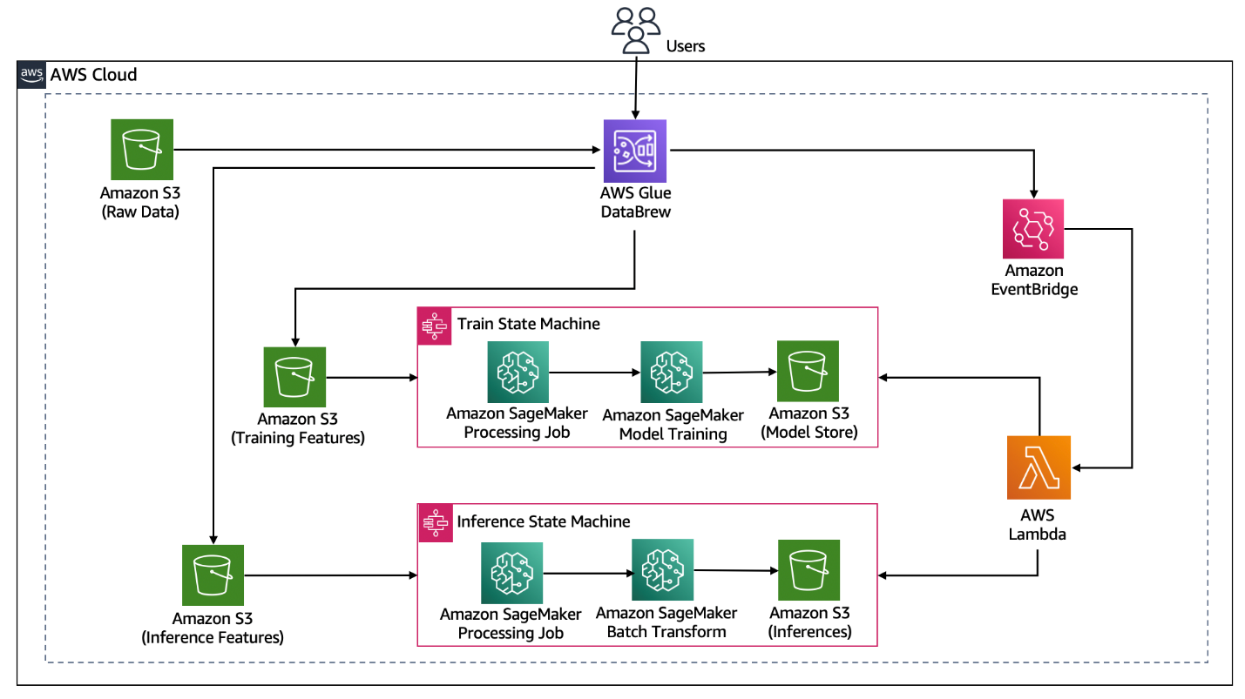

## Implement the feature engineering logic in each Lambda function.

To implement the feature engineering logic in each Lambda function, you will need to use a variety of machine learning techniques. Here are some examples:

* **Feature selection:** You can use a variety of feature selection techniques to select the most informative features from the data. Some popular feature selection techniques include:
  + **Information gain:** Measures the amount of information that a feature provides about the target variable.
  + **Chi-squared test:** Tests the independence between a feature and the target variable.
  + **Recursive feature elimination (RFE):** Recursively removes features until the performance of the machine learning model decreases.
* **Dimensionality reduction:** You can use dimensionality reduction techniques to reduce the number of features without losing too much information. Some popular dimensionality reduction techniques include:
  + **Principal component analysis (PCA):** Transforms the data into a new space where the features are uncorrelated.
  + **t-distributed stochastic neighbor embedding (t-SNE):** Projects the data into a lower-dimensional space while preserving the local structure of the data.
* **Feature transformation:** You can use feature transformation techniques to transform the features into a format that is more suitable for machine learning models. Some popular feature transformation techniques include:
  + **Log transformation:** Transforms the data by taking the logarithm of the values.
  + **One-hot encoding:** Encodes categorical features into binary features.
  + **Normalization:** Scales the features to have a mean of zero and a standard deviation of one.
* **Feature aggregation:** You can use feature aggregation techniques to aggregate the features over time or space to create more informative features. Some popular feature aggregation techniques include:
  + **Mean aggregation:** Calculates the mean of the features over a time period or spatial region.
  + **Max aggregation:** Calculates the maximum of the features over a time period or spatial region.
  + **Min aggregation:** Calculates the minimum of the features over a time period or spatial region.

The specific feature engineering techniques that you use will depend on the specific machine learning model that you are using and the specific problem that you are trying to solve.

Python

def remove_outliers(data):

"""Removes outliers from the data."""

# Calculate the interquartile range (IQR) for each feature.

iqr = np.percentile(data, 75) - np.percentile(data, 25)

# Identify any data points that are more than 1.5 IQRs below the first quartile or above the third quartile.

outliers = []

for i in range(len(data)):

for j in range(len(data.columns)):

if data.iloc[i][j] < np.percentile(data.iloc[:, j], 25) - 1.5 * iqr[j] or data.iloc[i][j] > np.percentile(data.iloc[:, j], 75) + 1.5 * iqr[j]:

outliers.append((i, j))

# Remove the outliers from the data.

for i, j in outliers:

data.drop(i, inplace=True)

return data

**STEP 1**

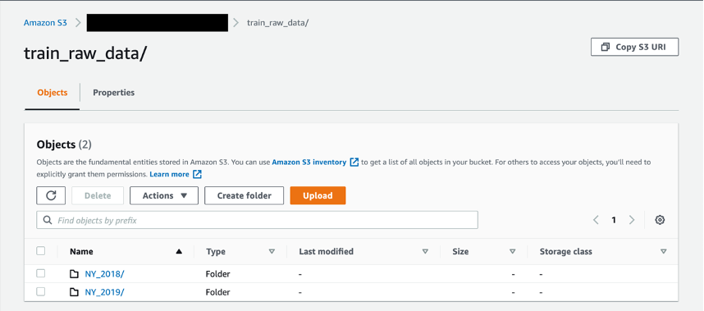

**STEP 2**

**Configure the Lambda functions to be invoked by AWS Kinesis.**

To configure the Lambda functions to be invoked by AWS Kinesis, you will need to create a Kinesis stream trigger for each Lambda function.

To create a Kinesis stream trigger for a Lambda function, follow these steps:

1. Open the Lambda console.
2. Choose the Lambda function that you want to add the trigger to.
3. Choose Triggers from the left-hand navigation pane.
4. Choose Add trigger.
5. Choose Kinesis from the Trigger type drop-down list.
6. Choose the Kinesis stream that you want to trigger the Lambda function from.
7. Choose Add.

Once you have added a Kinesis stream trigger to a Lambda function, the Lambda function will be invoked whenever new data is available in the Kinesis stream.

JSON

{

"Type": "Kinesis",

"Properties": {

"StreamName": "my-kinesis-stream"

}

}

This trigger will ensure that the data cleaning Lambda function is invoked whenever new data is available in the my-kinesis-stream stream.

You can create similar Kinesis stream triggers for the other Lambda functions that you develop to perform other feature engineering tasks.

Conclusion

In conclusion, feature engineering plays a crucial role in serverless IoT data processing for cloud app development. By carefully selecting, transforming, and extracting relevant features from raw IoT data, developers can enhance the performance and efficiency of their applications. This process aids in optimizing resource utilization, reducing latency, and improving data analysis and decision-making. Ultimately, effective feature engineering is a cornerstone of successful serverless IoT data processing, enabling developers to harness the full potential of cloud-based applications for IoT.